**Flieger- My Buddy**

**Transmitter (FS-i6)**

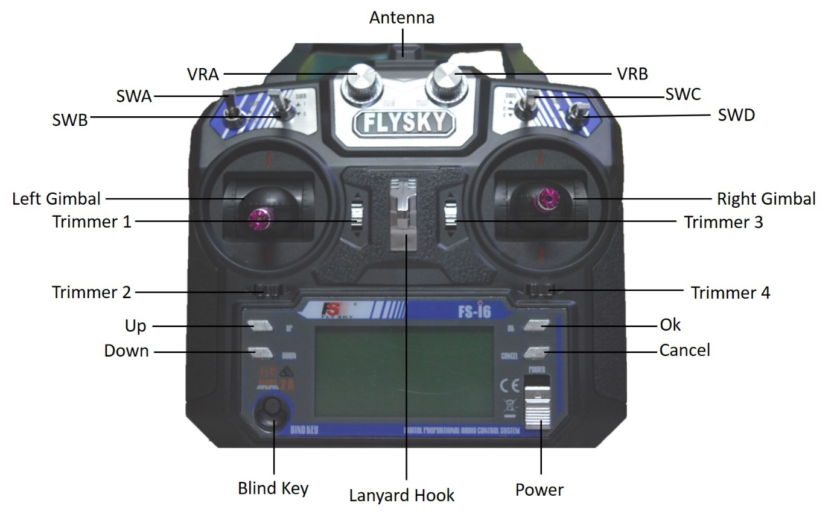

**Specifications:**

|  |  |
| --- | --- |
| **Channels** | **6** |
| **RF range** | **2.408-2.475 GHz** |
| **Bandwidth** | **500 kHz** |
| **Band** | **135** |
| **RF Power** | **< 20 dBm** |
| **Warning (Low Voltage)** | **<4.2 V** |
| **Power** | **6 V** |

**Receiver (FS-iA6B)**

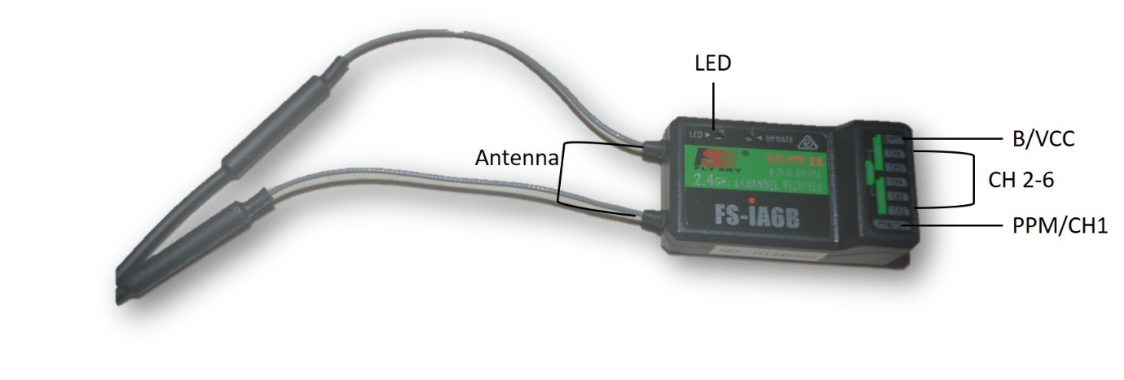

**Specifications:**

|  |  |
| --- | --- |
| **Channels** | **6** |
| **RF range** | **2.408-2.475 GHz** |
| **Band** | **135** |
| **RF Power** | **< 20 dBm** |
| **RX Sensitivity** | **-105 dBm** |
| **Power** | **4.0-6.5 V** |
| **ANT length** | **26 mm*2** |